**Latha**

**2403a51243**

**Batch:11**

**AI-ASSISTED-CODING**

**LAB-EXAM-2**

**Q)c1**

**Context:**

Contact records in the real estate listings platform CRM contain duplicates differing only by case

**Task:**

Return the first occurrence of each email (case-insensitive) while preserving original order.

**Data & Edge Cases:**

Input: list of emails. Normalize keys using lowercase; output retains original casing.

**Prompt:**

***“generate spot bug(reinitializing `seen` in loop) and correct to stable algorithm”***

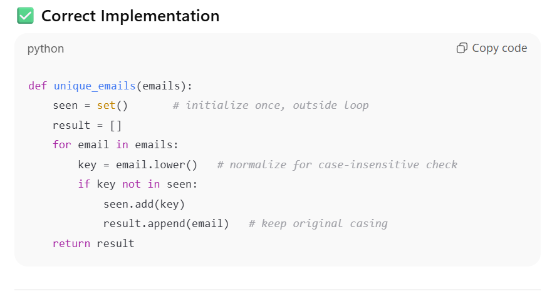

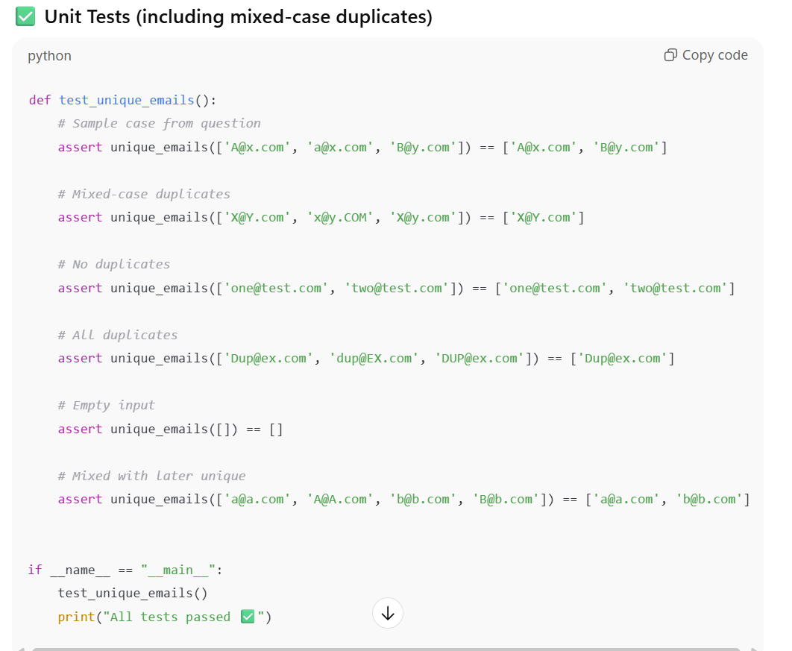

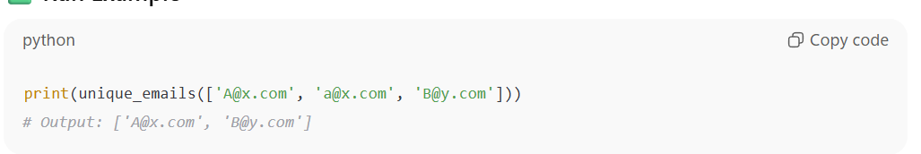

**Input:**

['A@x.com', 'a@x.com', 'B@y.com']

**Output:**

['A@x.com', 'B@y.com']

**Q)C2**

**Context:**

Titles in the real estate listings platform CMS must become SEO slugs.

**Task:**

TDD for slugify(text): lowercase, remove non-alnum except hyphen, spaces->hyphen, collapse and trim hyphens.

**Data & Edge Cases:**

Include punctuation and multiple spaces.

Have AI propose parametric tests then implement regex solution.

**Prompt:**

***“ generate TDD for slugify(text): lowercase, remove non-alnum except hyphen, spaces->hyphen, collapse and trim hyphens***

***AI propose parametric tests then implement regex solution.”***

